Project Report

Enforcing Mandatory Fields Using UI Policies and Migrating Changes with Update Sets
Platform: ServiceNow

1️. Introduction&Project Overview

Definition
This project focuses on enforcing mandatory fields dynamically using UI Policies in ServiceNow and migrating those configurations safely across instances using Update Sets.
The goal is to:
- Improve data accuracy
- Prevent incomplete record submissions
- Ensure structured deployment from Development → Test → Production

Project Overview Box
Field | Details
Project Title | Enforcing Mandatory Fields Using UI Policies and Migrating Changes with Update Sets
Platform | ServiceNow
Module | UI Policies&Update Sets
Objective | Enforce mandatory fields dynamically and migrate changes securely
Scope | Incident Table
Instances | Dev, Test, Production
Outcome | Improved data quality&structured deployment

2️. Business Requirement

Definition
The business requires that certain fields must be mandatory when an Incident is moved to Resolved state to ensure proper closure documentation.
This improves:
- Reporting accuracy
- Audit compliance
- Knowledge base generation
- Root cause tracking

Business Requirement Box
Field | Description
Requirement ID | BR-001
Table | Incident
Condition | State = Resolved
Mandatory Fields | Resolution Code, Resolution Notes
Justification | Prevent incomplete ticket closure
Priority | High

3️. UI Policy Configuration

Definition
A UI Policy is configured to make specific fields mandatory when the Incident state changes to Resolved.

UI Policy Configuration Screenshot
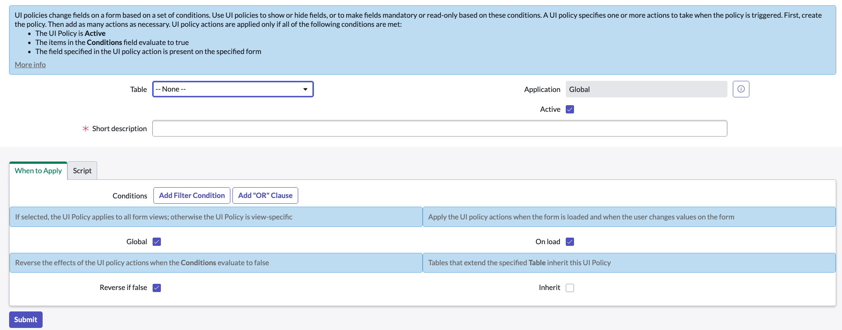
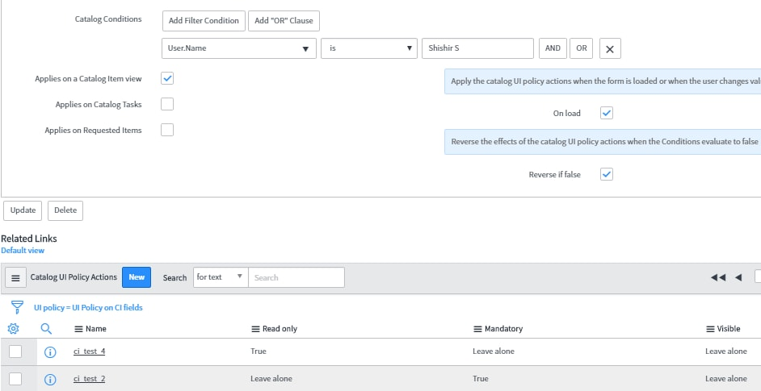
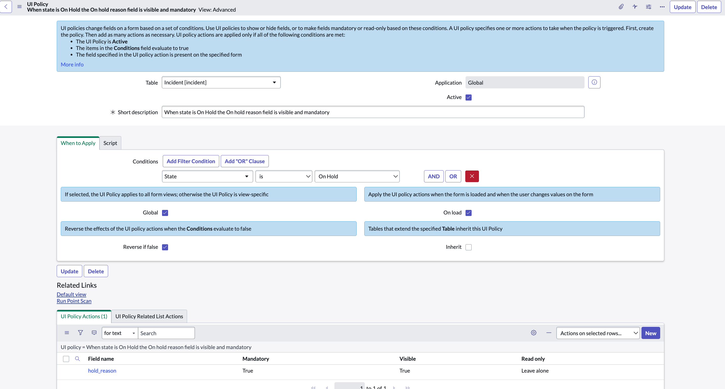
4

UI Policy Configuration Box
Field | Value
UI Policy Name | Enforce Mandatory Fields on Resolution
Table | Incident
Condition | State = Resolved
On Load | True
Reverse If False | True
Description | Makes resolution fields mandatory before closure

4️. UI Policy Actions

Definition
UI Policy Actions define how specific fields behave when the UI Policy condition is met.
Fields can be set to:
- Mandatory
- Visible
- Read-only

UI Policy Action Screenshot
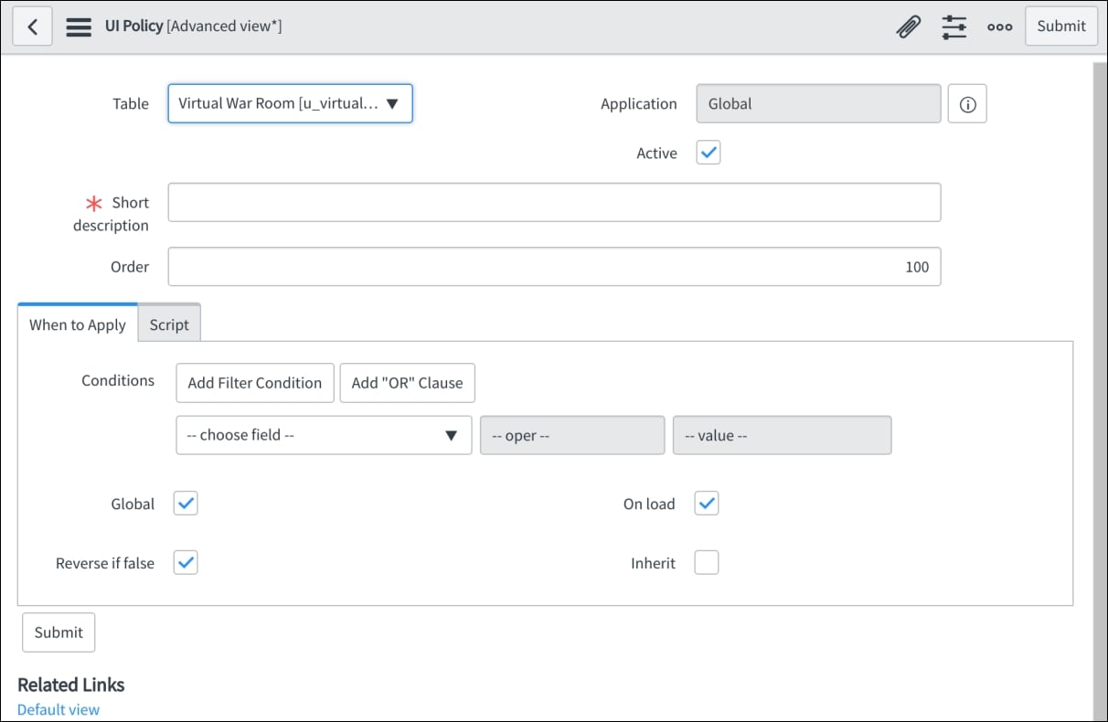
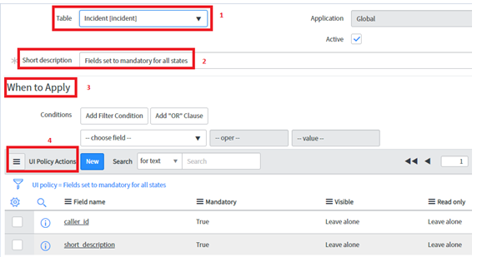
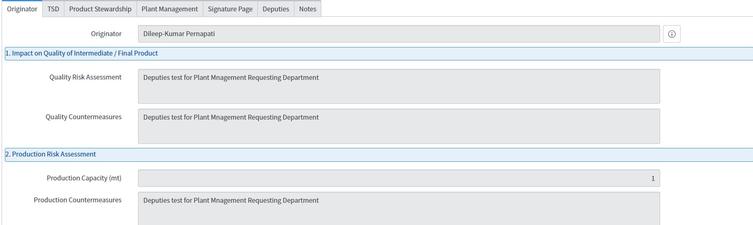
4

UI Policy Action Box
Field Name | Mandatory | Visible | Read-Only
Resolution Code | True | True | False
Resolution Notes | True | True | False
Close Notes | True | True | False

5️. Testing&Validation

Definition
Testing ensures that:
- Fields become mandatory when State = Resolved
- Fields revert when condition is false
- Users cannot close the ticket without required data

Testing Scenario Screenshot
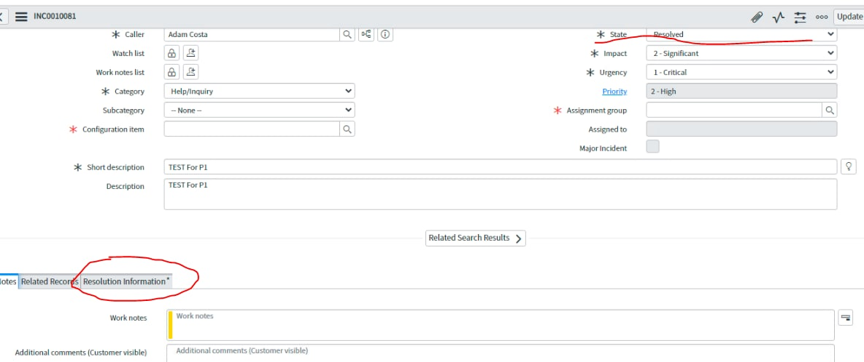
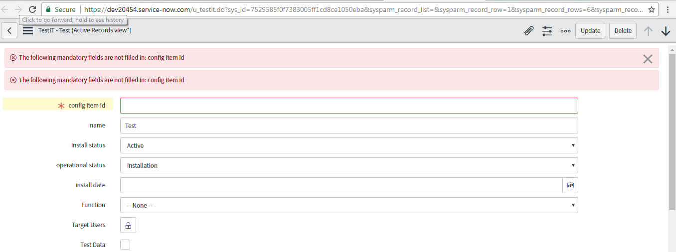
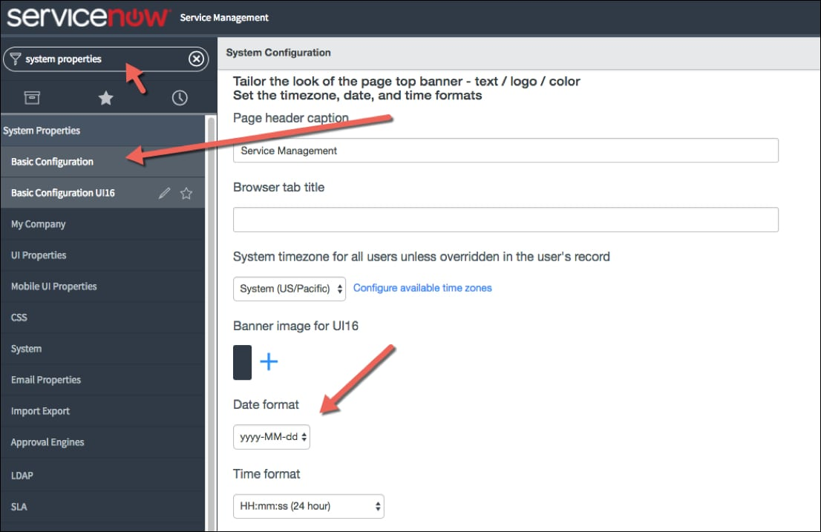
4

Testing & Validation Box
Test Case ID | Scenario | Expected Result | Status
TC-01 | Change state to Resolved | Fields become mandatory | Pass
TC-02 | Remove required field | Error message appears | Pass
TC-03 | Revert state | Fields no longer mandatory | Pass
Validated By: __________
Test Date: __________

6️. Update Set Migration

Definition
Update Sets capture configuration changes and allow migration between instances.
Steps:
- Create Update Set
- Capture changes
- Complete Update Set
- Export XML
- Import to Target Instance
- Preview&Resolve Conflicts
- Commit

Update Set Screenshot
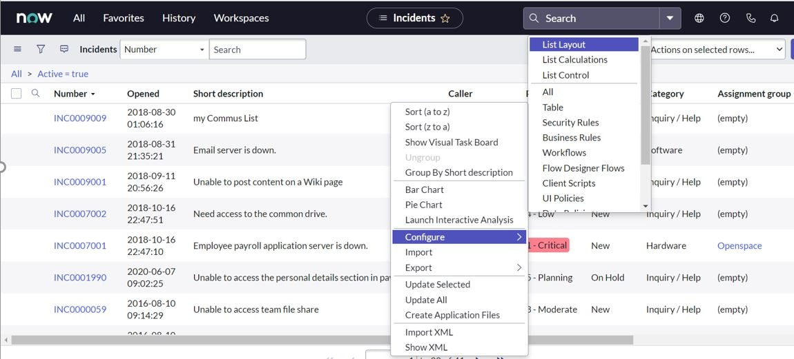

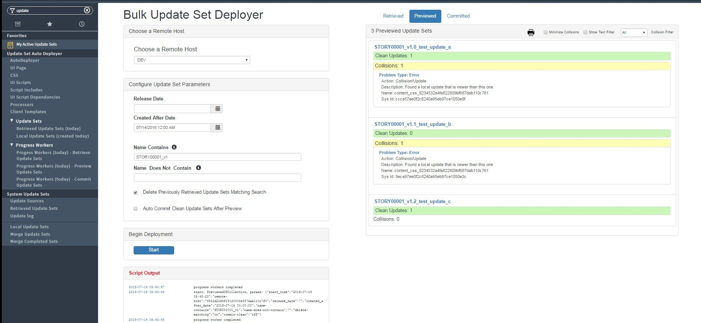
4

Update Set Details Box
Field | Value
Update Set Name | Mandatory Fields Enforcement v1
Source | Development
Target | Test / Production
Components | UI Policy, UI Policy Actions
Review Status | Approved
Backout Plan | Revert to previous Update Set

7️. Risk&Governance

Definition
Proper governance ensures safe deployment and prevents production disruption.

Risk Management Box
Risk ID | Description | Impact | Mitigation
R-01 | Blocking ticket closure | Medium | Test thoroughly
R-02 | Update Set conflict | High | Preview before commit
R-03 | Production error | High | Maintain rollback plan

